**Assignment 1 – Northwind Database**

* **Creating Database:**

CREATE DATABASE northwind;

* **Creating Tables**

1. Category

CREATE TABLE Categories(

CategoryID INT IDENTITY(1, 1) PRIMARY KEY,

CategoryName VARCHAR(15) NOT NULL,

Description VARCHAR(250)

);

1. Suppliers

CREATE TABLE Suppliers(

SupplierID INT IDENTITY(1, 1) PRIMARY KEY,

CompanyName VARCHAR(40) NOT NULL,

ContactName VARCHAR(30),

ContactTitle VARCHAR(30),

Address VARCHAR(60),

City VARCHAR(15),

Region VARCHAR(15),

PostalCode VARCHAR(10),

Country VARCHAR(15),

Phone VARCHAR(24),

Fax VARCHAR(24),

HomePage VARCHAR(250)

);

1. Products

CREATE TABLE Products(

ProductID INT IDENTITY (1, 1) PRIMARY KEY,

ProductName VARCHAR(40) NOT NULL,

SupplierID INT,

CategoryID INT,

QuantityPerUnit VARCHAR(20),

UnitPrice DECIMAL(10, 4),

UnitsInStock SMALLINT,

UnitsOnOrder SMALLINT,

ReorderLevel SMALLINT,

Discontinued BIT NOT NULL,

FOREIGN KEY (SupplierID) REFERENCES Suppliers(SupplierID),

FOREIGN KEY (CategoryID) REFERENCES Categories(CategoryID)

);

* **Queries**

1. SELECT ProductID, ProductName, UnitPrice

FROM Products

WHERE Discontinued = 0 AND UnitPrice < 20;

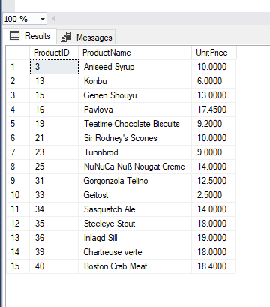

1. SELECT ProductID, ProductName, UnitPrice

FROM Products

WHERE UnitPrice > 15 AND UnitPrice < 25;

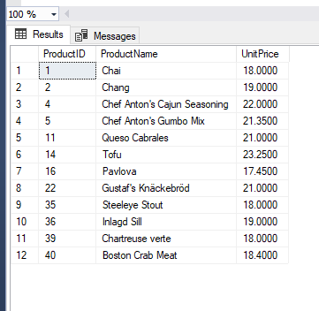

1. SELECT ProductName, UnitPrice

FROM Products

WHERE UnitPrice > (

SELECT AVG(UnitPrice)

FROM Products

);

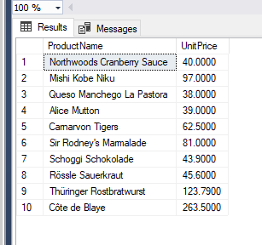

1. SELECT TOP 10 ProductName, UnitPrice

FROM Products

ORDER BY UnitPrice DESC;

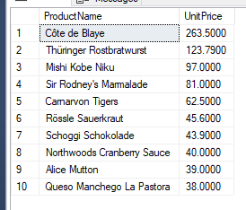

1. SELECT Discontinued, COUNT(*) AS Count

FROM Products

GROUP BY Discontinued;

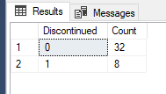

1. SELECT ProductName, UnitsOnOrder, UnitsInStock

FROM Products

WHERE UnitsInStock < UnitsOnOrder;

